**Ikebana-Level 1 (Intro) Supply List**

**Must Have:**

* Ikebana scissors (small pair of plant clippers could be used) and a pair of utility scissors.
* Shallow container (round, oval, half circle or rectangular) ~10-14 inches and about 2-3 inches deep.

Below are some container shapes used for basic flower arranging. You can find them online (or find a suitable container at local store).

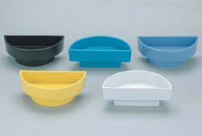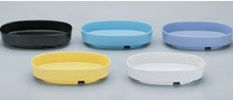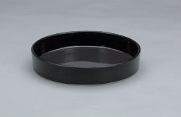

* Kenzan (pin holder or frog) ~ 2.5” round rectangular is a good size to start with, but fan or round shapes are OK too!

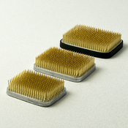 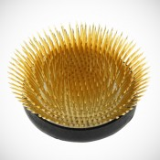 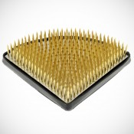

Local craft stores sometimes carry them; make sure they are heavy enough to support weight of the long & heavy branches.

* Clippers: below is an example, but you can use a plant clipper.

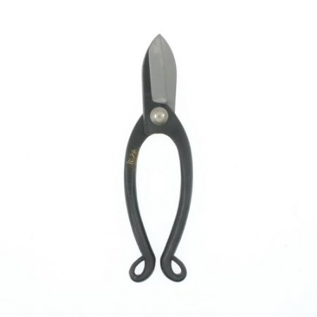

* Plastic floral bag and newspaper to wrap flowers for transportation to home.

**Good to have:**

* Kitchen towel
* Spray bottle with water
* A digital photography device to take pictures of the arrangement at class for reference when you put the arrangement back together at home.